**Solution 1**

First solution to that i think for this homework is first curve dealing with the purple area and second curve dealing with the blue area so I split array with their slope than after that i make my calculations.

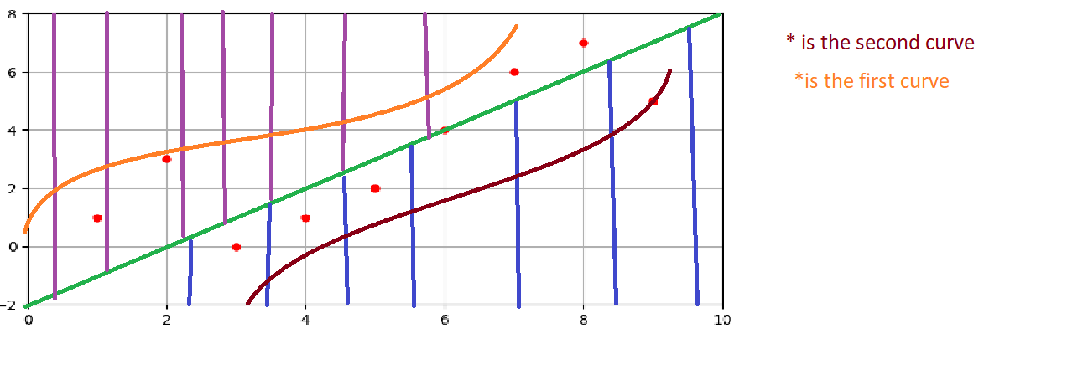

Here my result with this solution i also add some different dots to my data.

NOTE: The Code is for this in my github.

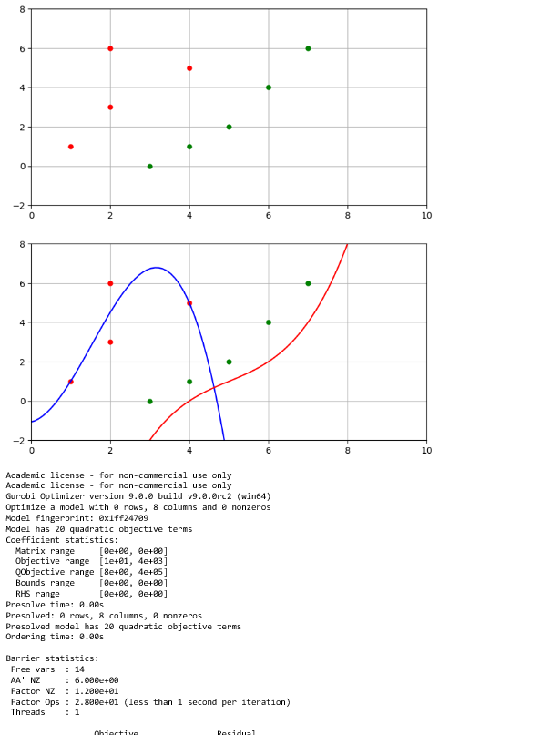

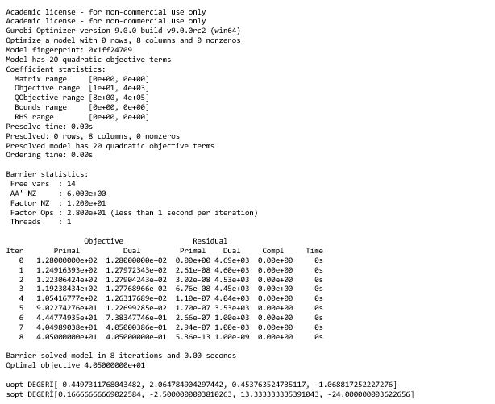

**Solution 2**

After this solution i think that seperating dots can be randomly like idea of Ransac.Here my code but i got some error that i cant solve :/

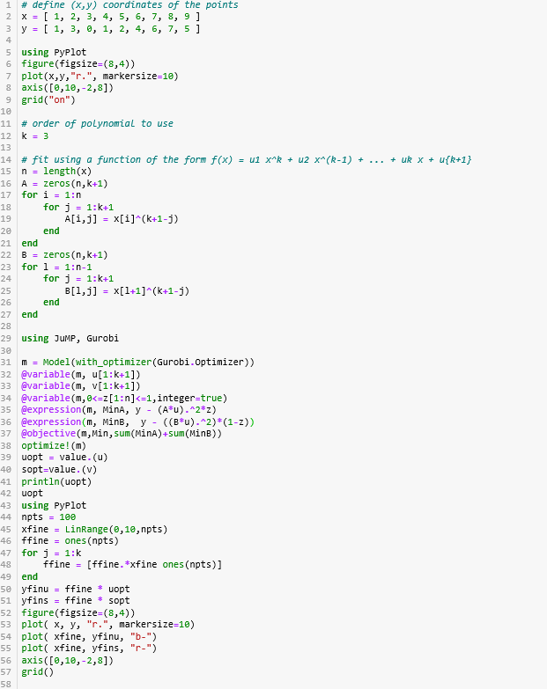

Here my wrong output :

